Q-1 What is software? What is software engineering?

Ans: -

Software: - software is a set of instruction, data or programs used to operate computers and execute specific tasks. It is opposite of hardware, which describes the physical aspects of a computer.

Software engineering: - software engineering is a branch associated with development of software product using well-defined scientific principles, methods and procedures.

Q-2 Explain types of software?

Ans: -

Application software: - Application software is a computer software package that performs a specific function for a user or in some cases for another application. An application can be elf-contained or it can be a group of programs that run the application for the user.

Examples: - web browsers, word processors, Instagram WhatsApp.

System software: - these software programs are designed to run a computer’s application programs and hardware. System software coordinates the activities and functions of the hardware and software.

It controls the operations of the computer hardware and provides an environment or platform for all the other types of software to work in.

Examples: - windows, Linux, macOS, Android.

Q-3 what us SDLC? Explain each phase of SDLC?

Ans: -

Software Development Life Cycle (SDLC): - SDLC is a process used by the software industry to design, develop and test high quality software. The SDLC aims to produce a high-quality software that meets or exceeds customer expectations, reaches completion within times and cost estimates.

* SDLC is the acronym of Software Development Life Cycle.
* It is also called as Software Development Process.
* SDLC is a framework defining tasks performed at each step in the software development process.
* ISO/IEC 12207 is an international standard for software life-cycle processes. It aims to be the standard that defines all the tasks required for developing and maintaining software.

The following figure is a graphical representation of the various stages of a typical SDLC.

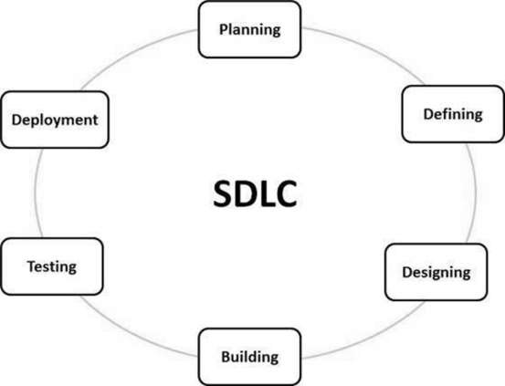

A typical Software Development Life Cycle consists of the following stages –

1. Planning and Requirement Analysis: -

* Requirement analysis is the most important and fundamental stage in SDLC. It is performed by the senior members of the team with inputs from the customer, the sales department, market surveys and domain experts in the industry.

2. Defining Requirements: -

* Once the requirement analysis is done the next step is to clearly define and document the product requirements and get them approved from the customer or the market analysts. This is done through an **SRS (Software Requirement Specification)** document which consists of all the product requirements to be designed and developed during the project life cycle.

3. Designing the Product Architecture: -

* SRS is the reference for product architects to come out with the best architecture for the product to be developed. Based on the requirements specified in SRS, usually more than one design approach for the product architecture is proposed and documented in a DDS - Design Document Specification.

4. Building or Developing the Product: -

* In this stage of SDLC the actual development starts and the product is built. The programming code is generated as per DDS during this stage. If the design is performed in a detailed and organized manner, code generation can be accomplished without much hassle.

5. Testing the Product: -

* This stage is usually a subset of all the stages as in the modern SDLC models, the testing activities are mostly involved in all the stages of SDLC. However, this stage refers to the testing only stage of the product where product defects are reported, tracked, fixed and retested, until the product reaches the quality standards defined in the SRS.

6. Deployment in the Market and Maintenance: -

* Once the product is tested and ready to be deployed it is released formally in the appropriate market. Sometimes product deployment happens in stages as per the business strategy of that organization. The product may first be released in a limited segment and tested in the real business environment (UAT- User acceptance testing).

Q-4 what is DFD? Create a DFD diagram on Flipkart?

Ans: -

**DFD** is the abbreviation for **Data Flow Diagram**. The flow of data of a system or a process is represented by DFD. It also gives insight into the inputs and outputs of each entity and the process itself. DFD does not have control flow and no loops or decision rules are present. Specific operations depending on the type of data can be explained by a flowchart.

DFD diagram for Flipkart: -

